**CONCEPTS OF ETHICAL HACKING LAB**

**WEEK – 8**

**Jcryptool and Demonstration of Symmetric key Crypto Algorithm and Digital Signature/PKI**

Demonstrating practical usage of symmetric key cryptography algorithm and digital signature/PKI using Jcryptool.

**Requirements:**

1. Jcryptool.

**Procedure:**

1. Download Jcryptool from www.cryptool.org and extract it.
2. Run JCrypTool.exe as administrator.
3. Open a new text and save it after writing a message on it.
4. Now open the Algorithms option from the upper left corner and select the AES algorithm from Symmetric algorithms.
5. Now create a New Key pair in the keystore using the users name as contact name and user password.
6. 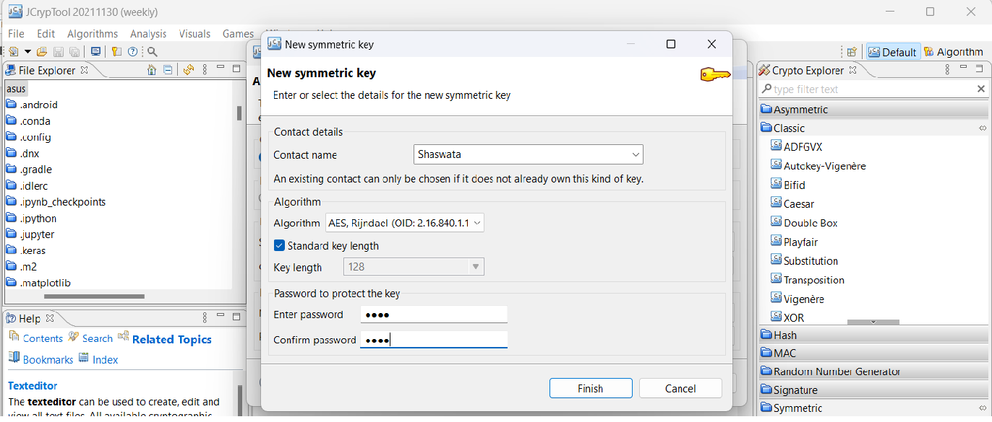
7. Encrypt the plain text/message using the new key pair and the password.
8. Graphical user interface, text, application, email

   Description automatically generated
9. Graphical user interface, application, Word

   Description automatically generated
10. To decrypt the encrypted message again open the AES algorithm and select the decrypt option.
11. A screenshot of a computer

    Description automatically generated
12. Users must choose the same key pair and give the user password when asked.
13. Graphical user interface, application, Word

    Description automatically generated
14. For signaturing a file select DSA from Digital Signature and create a new key pair also store it.
15. 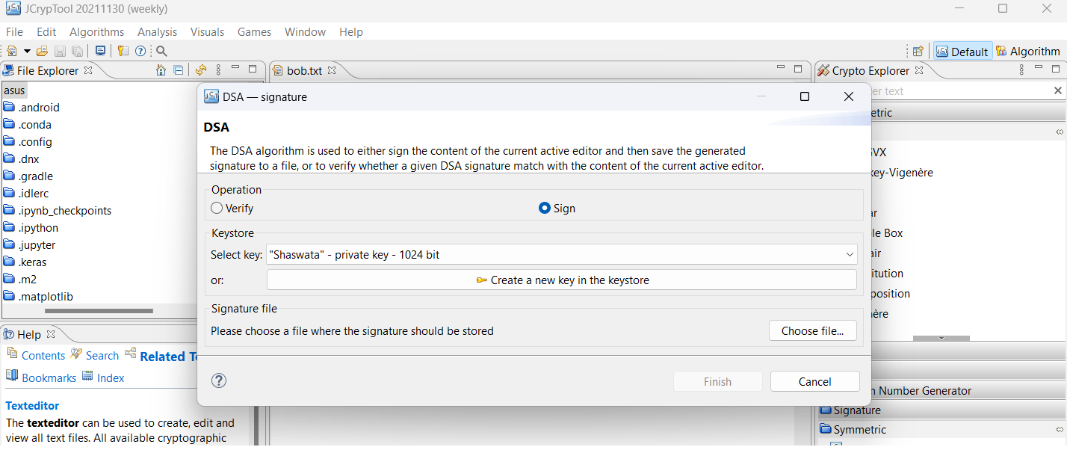
16. Now the file is digitally signed and to verify it select the DSA again from digital signature and select the stored key and give the password.
17. 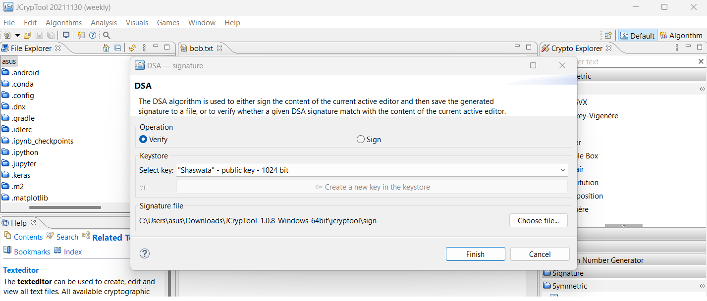
18. And it will show a message that it is valid.
19. Graphical user interface, text, application

    Description automatically generated

----END---